Ideation Phase

Brainstorm & Idea Prioritization

|  |  |
| --- | --- |
| Date | 22 September 2022 |
| Team ID | PNT2022TMID36392 |
| Project Name | Nutrition Assistant Application |
| Maximum Marks | 4 Marks |

Step-1: Team Gathering, Collaboration and Select the Problem Statement

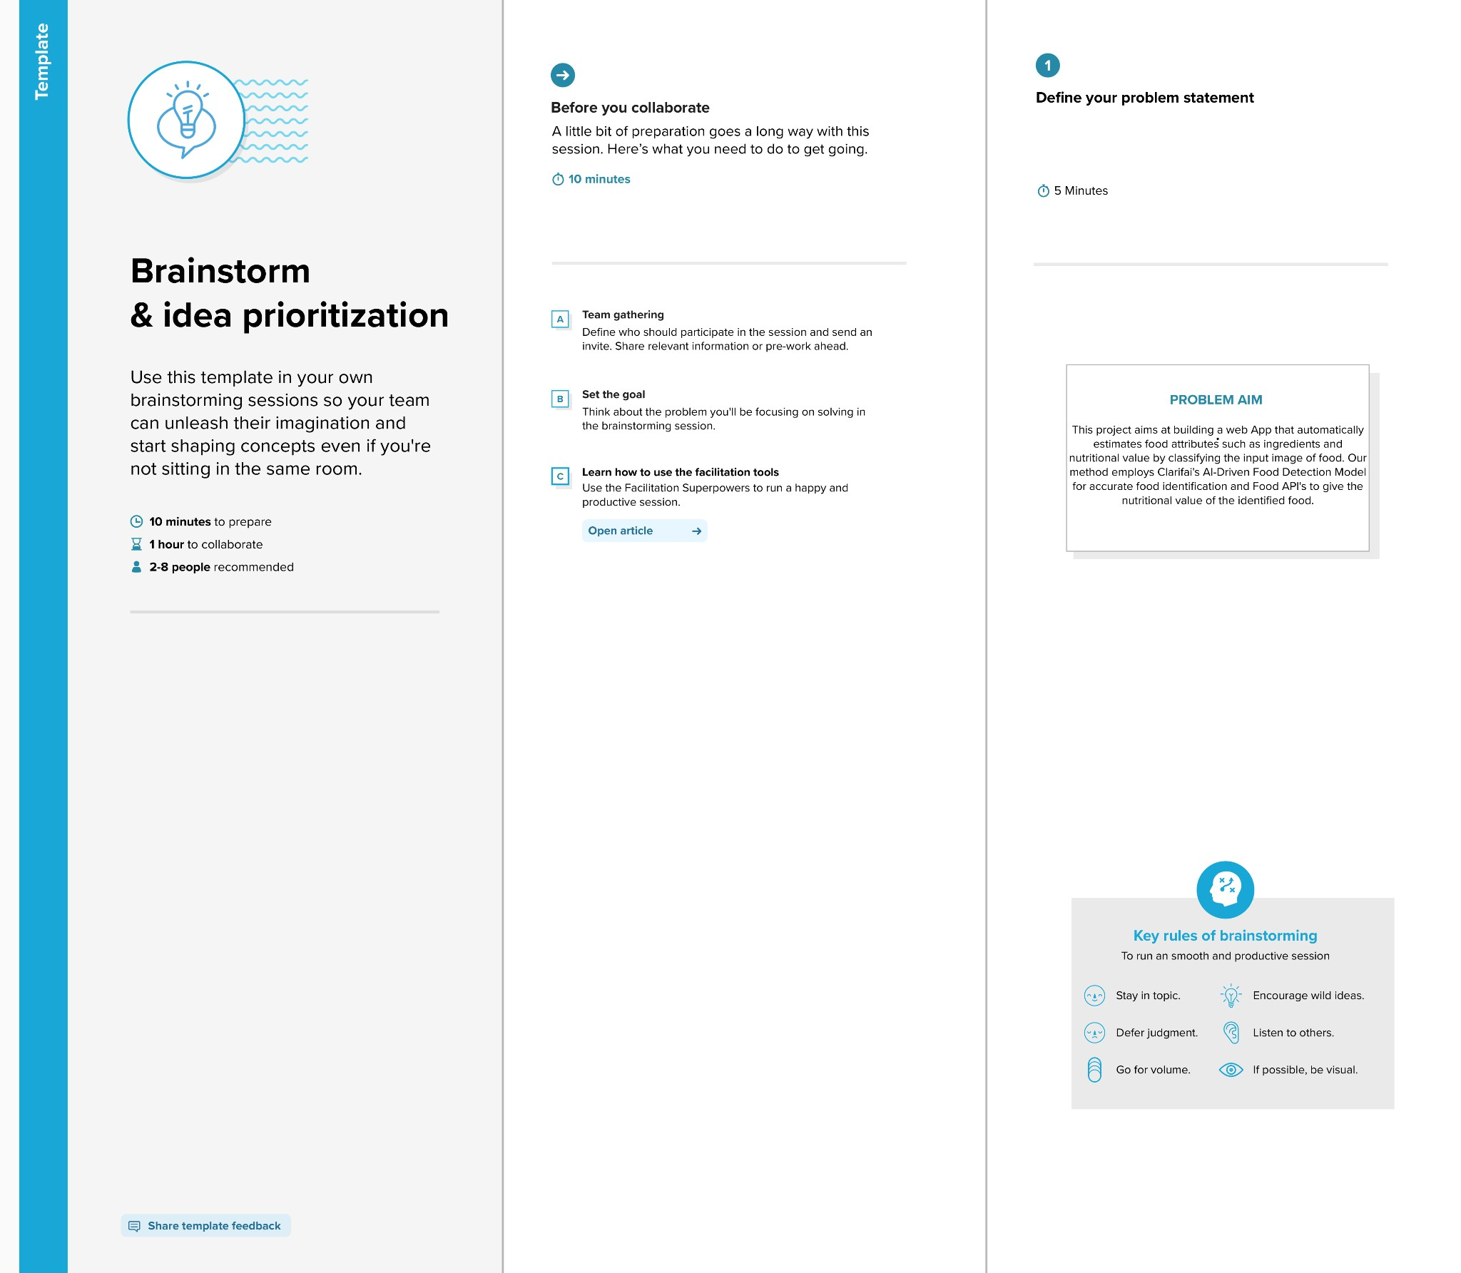

Step-2: Brainstorm, Idea Listing and Grouping

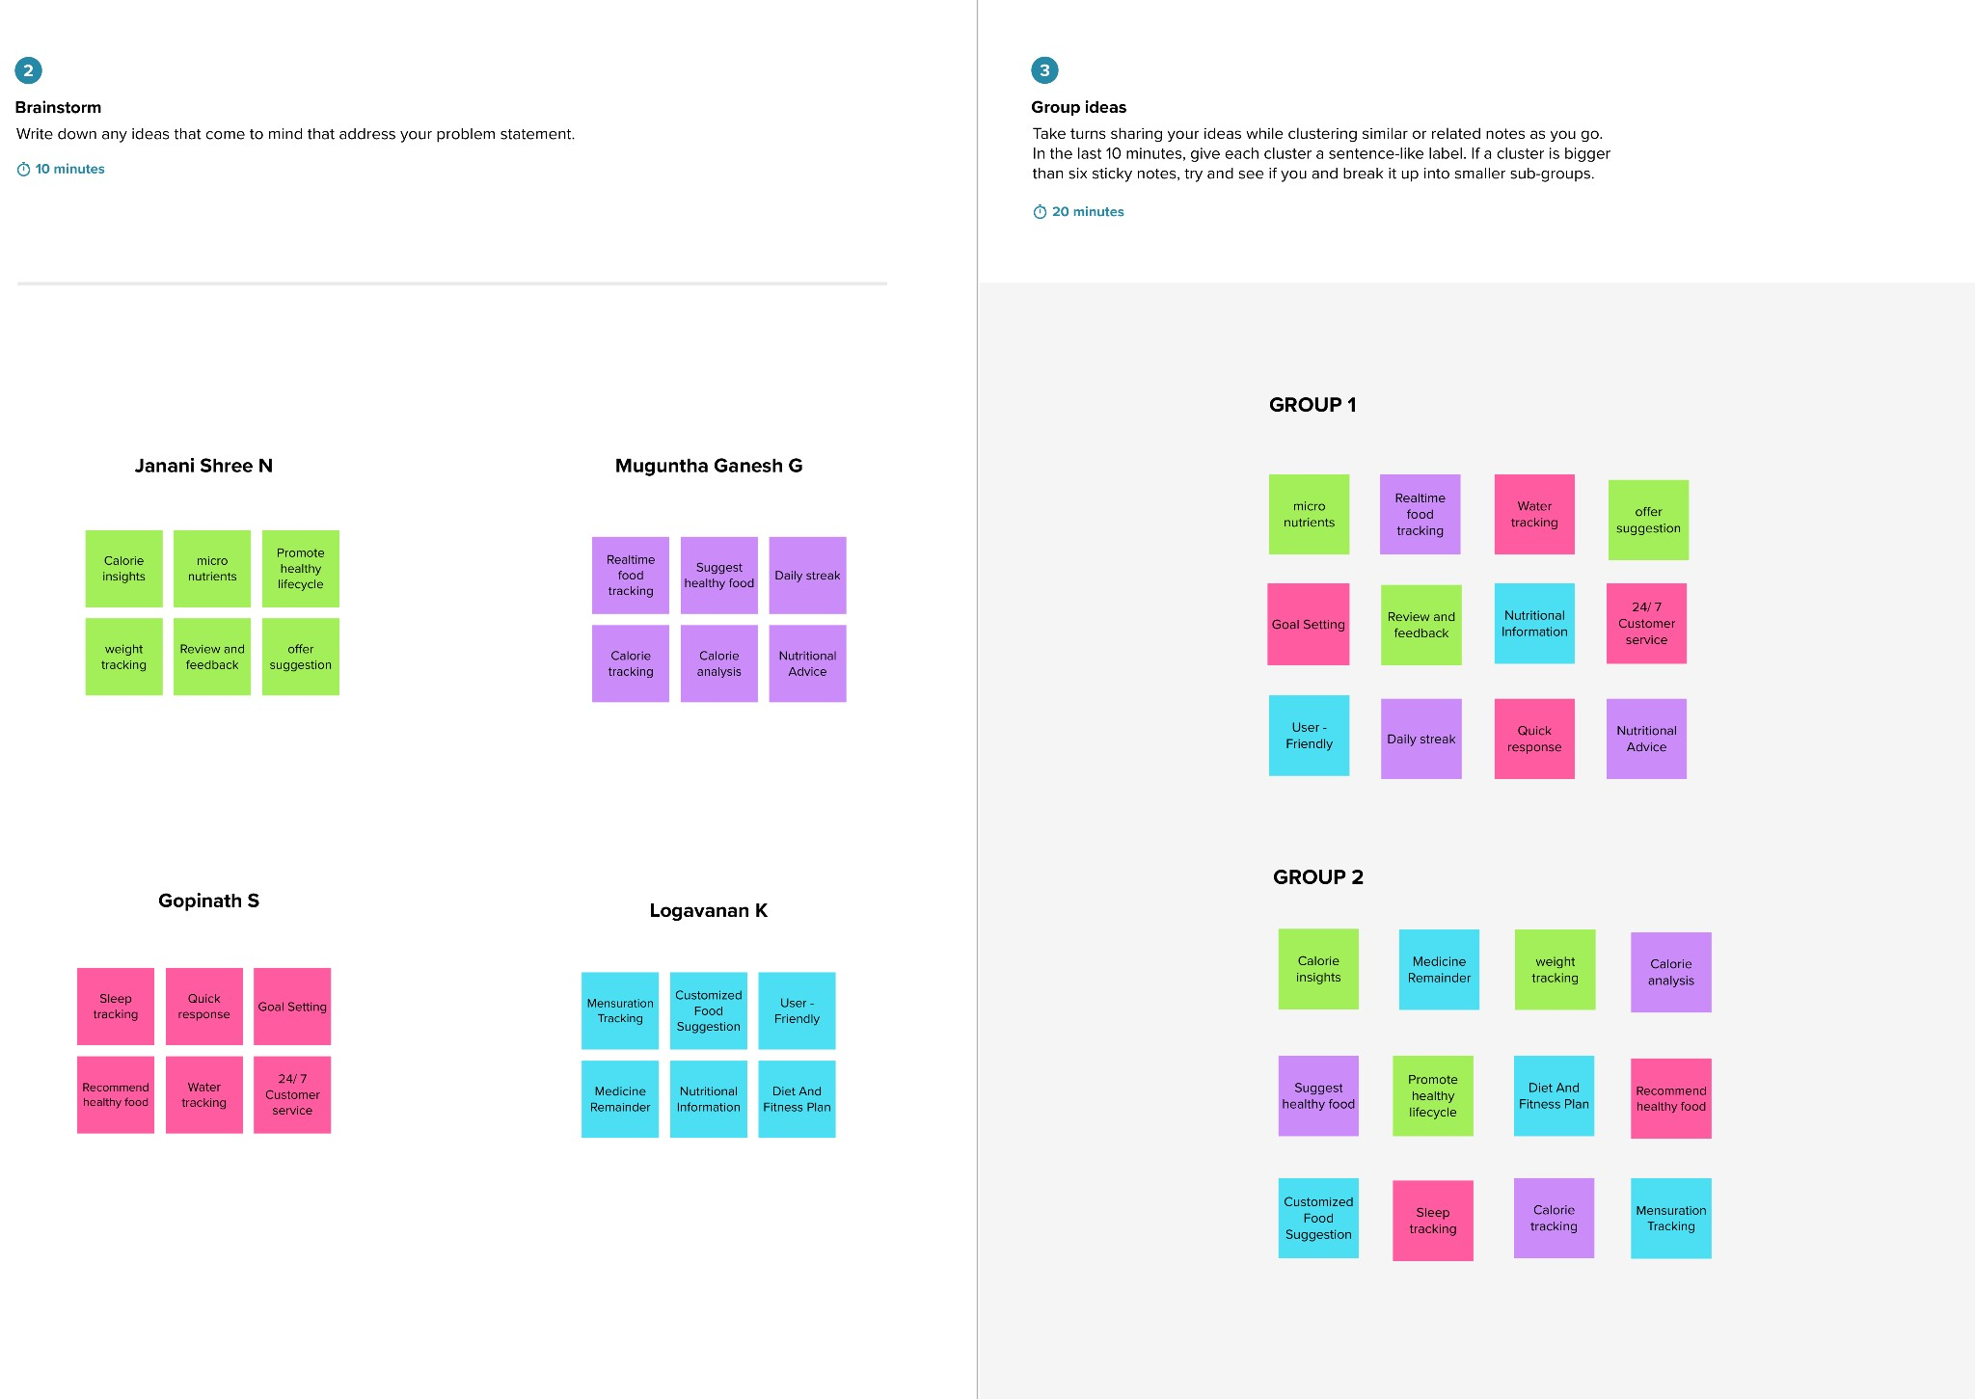

Step-3: Idea Prioritization

